OQPSK Modulator

The modulator turns a stream of bits into the radio waveform defined by IEEE 802.15.4 for the 2.4 GHz band. It is written in Python using NumPy, runs in four stages, and passes all four of its verification checks: the signal strength is constant to nine decimal places, the phase moves in exact quarter-turns, and bits sent through the modulator and back out of the demodulator come back identical.

How it works at a glance
The modulator has four stages. The first two turn data into a code, the last two turn that code into a waveform.
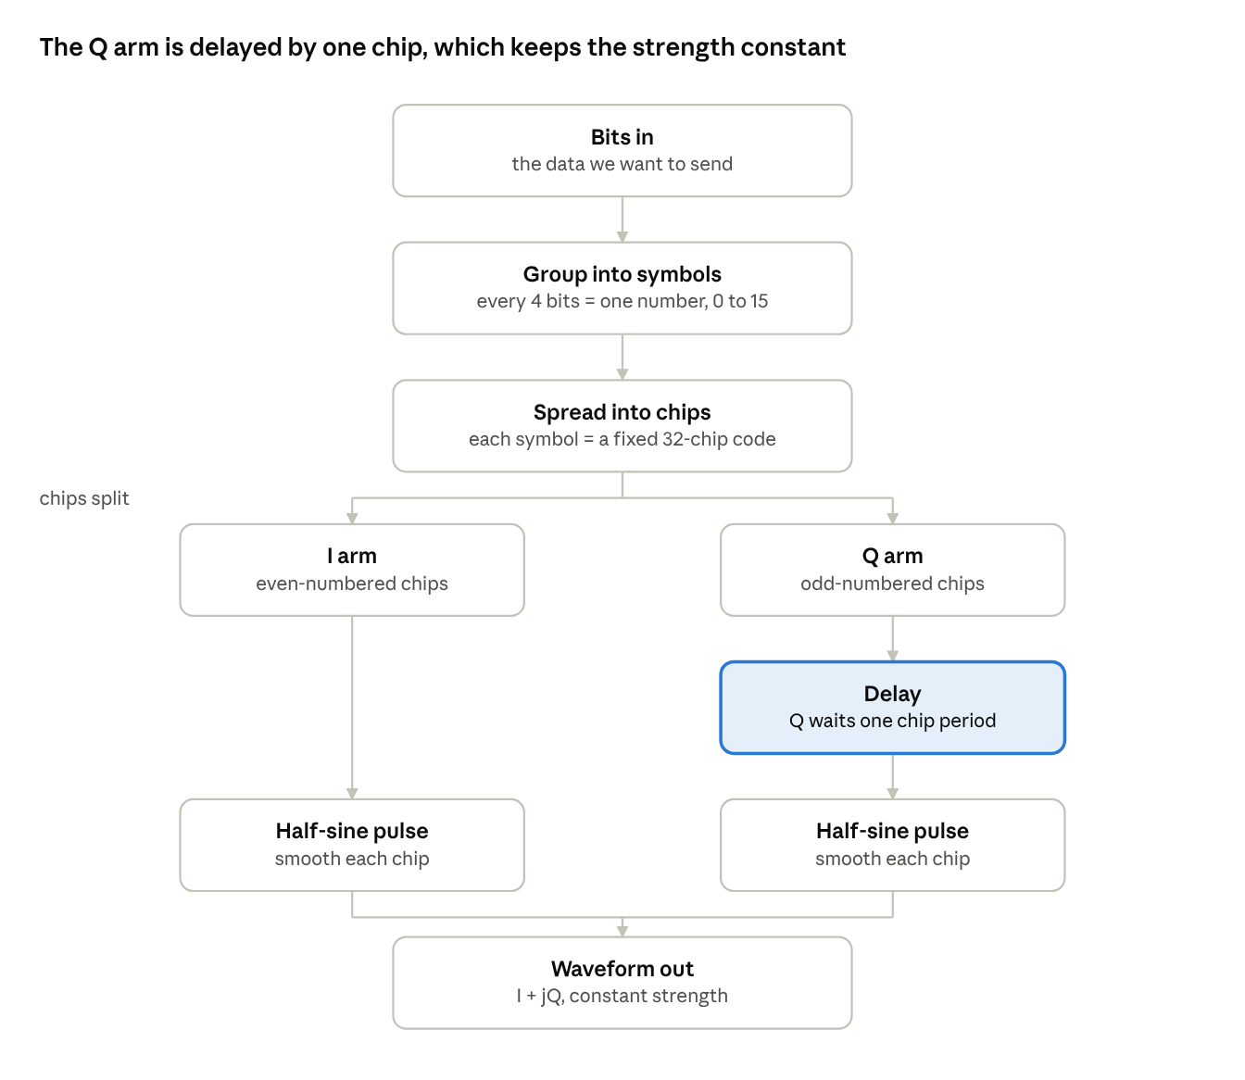
OQPSK modulator · 4 stages, 2 arms
The only unusual step is the delay on the Q arm. Without it the two arms would change value at the same instant and the signal strength would dip to zero. With it, one arm is always at full strength while the other passes through zero, so the total never varies.

Step 1 — Bits become symbols
Bits arrive one after another. The modulator takes them four at a time and turns each group into a single number between 0 and 15.
bits 1 0 1 1 0 0 0 1
symbols 13 8
The code does this in three lines:
def bits_to_symbols(bits):
nibbles = bits.reshape(-1, 4) # cut the stream into rows of four
weights = 1 << np.arange(4) # place values: 1, 2, 4, 8
return (nibbles * weights).sum(axis=1)
reshape(-1, 4) cuts the long line of bits into rows of four. The -1 means work out how many rows that makes — we do not have to count. 1 << np.arange(4) is a quick way to write the place values 1, 2, 4, 8. Multiplying a row by those place values and adding the result up gives the number that row stands for.
Why four at a time? Because the codebook in the next step has sixteen entries, and four bits is exactly enough to pick one of sixteen. Nothing is gained or lost in this step — four bits and "a number from 0 to 15" hold the same information. The regrouping only makes the next step possible.
One detail is easy to get wrong. The standard sends the lowest-value bit first, so 1 0 1 1 is 1 + 0 + 4 + 8 = 13, not 11. Reading it the other way round produces a signal that looks perfectly healthy and decodes to the wrong data.

Step 2 — Symbols become chips
Each symbol is looked up in a codebook of sixteen entries. Every entry is a fixed pattern of 32 values, each either +1 or −1. Those values are called chips.
symbol 0 → 1 1 0 1 1 0 0 1 1 1 0 0 0 0 1 1 0 1 0 1 0 0 1 0 0 0 1 0 1 1 1 0
The codebook comes straight from the IEEE 802.15.4 standard. In the code it is a 16-row, 32-column array, and the lookup is a single line:
def spread(symbols):
return CHIP_TABLE_PM1[symbols].reshape(-1)

NumPy lets you index an array with a whole list of row numbers at once. CHIP_TABLE_PM1[symbols] fetches one row per symbol and stacks them, and .reshape(-1) flattens the stack back into one long chip stream.
So four bits have become 32 chips — eight times more than we need. That waste is the whole point.
The receiver never has to get the chips right. It compares what it heard against all sixteen entries and picks the closest one. The entries were chosen so that any two of them differ in at least sixteen of their 32 positions, so five or six chips can be completely wrong and the correct entry still wins clearly.
It is like sending "Bravo" instead of the letter B. If three letters get mangled into "Brxvq" it is still obviously Bravo and not Charlie. That redundancy is what lets a sensor on a coin cell be heard at the far end of a building, and it is worth roughly 9 dB of extra range.
The sixteen entries also have a hidden pattern: rows 0 to 7 are the same row rotated by four places each time, row 8 is row 0 with every second value flipped, and rows 8 to 15 are rotations of row 8. A receiver that knows this can do one comparison eight ways instead of sixteen separate ones — about eight times less work. The code checks this pattern holds every time it runs.

Step 3 — Two channels, one delayed
This is the step the modulation is named after, and it is where most of the thinking sits.
The chip stream is split in two. Even-numbered chips go to one channel, odd-numbered chips to the other. They are called I and Q, and they travel together as the real and imaginary parts of one complex signal.
a_i = chips[0::2] # chips 0, 2, 4, … → I arm
a_q = chips[1::2] # chips 1, 3, 5, … → Q arm
chips[0::2] reads as start at 0 and take every second one. Each arm ends up with half the chips, so a new value arrives on each arm only every two chip periods.
Next the chip values are placed at the moments in time they belong to, with zeros in between. Before this point the code was counting chips; from here on it is building a signal, and it needs a sampling rate. sps is how many samples we use per chip — like the frame rate of a video.
step = 2 * sps # a new chip per arm every two chip periods
imp_i[0 : n_arm * step : step] = a_i # I chips at 0, 2·sps, 4·sps, …
imp_q[sps : sps + n_arm * step : step] = a_q # Q chips at the same spacing, sps later
The whole delay is that single sps at the start of the second line. The Q chips are written one chip period further along than the I chips. One number, and it is the reason the modulation exists.
Why the delay matters. Without it, both arms would change value at the same instant. When both flip sign together the signal passes through zero — the transmitter goes briefly silent, then comes back. An amplifier driven hard does not handle that cleanly, and the distortion splashes into neighbouring channels.
With the delay, the two arms take turns. Whenever one arm is at the top of its pulse, the other is passing through zero. Add them together and the total strength comes out the same at every instant: the signal never gets louder or quieter, it only rotates. That lets the power amplifier run flat out, which is where amplifiers are efficient, and efficiency is battery life.
The detail to get right: the delay is one chip period, not half of one. The confusion is understandable, because one chip period is half a symbol period on each arm, and the pulse in the next step lasts two chip periods. Getting this wrong breaks the constant-strength property, which is the one thing this modulation exists to provide.

Step 4 — Smoothing each chip
Each chip now has to become a real shape in time. The obvious choice is a square block: hold at +1 for a while, then jump to −1.
The problem is the jump. A sudden edge in time spreads energy across an enormous range of frequencies, and that energy lands in the channels either side of ours. The standard therefore calls for a smooth hump instead — the half-sine:
def half_sine(sps):
n = np.arange(2 * sps)
return np.sin(np.pi * (n + 0.5) / (2.0 * sps))
The hump lasts two chip periods. That sounds like it should cause trouble, but remember from step 3 that each arm only gets a new chip every two chip periods. So neighbouring humps on the same arm sit exactly side by side — they never overlap, and no chip interferes with its neighbour.
Applying the shape is one call:
i_wave = np.convolve(imp_i, p)[:length]
q_wave = np.convolve(imp_q, p)[:length]
return i_wave + 1j * q_wave
Convolution sounds intimidating but here it does something simple: the impulse train from step 3 is mostly zeros with a value spike every so often, and convolving it with the hump stamps a copy of the hump at each spike, scaled by +1 or −1. The last line glues the two arms together as one complex signal — 1j is how Python writes the imaginary unit.
A bug worth recording. The natural way to write the hump is sin(πn / 2·sps). It looks right and it is wrong. Sampling at whole numbers makes the discrete hump lopsided — it starts at exactly zero but does not end at zero — which shifts its centre half a sample off the grid. The receiver then loses a slice of signal strength: about 3 dB at two samples per chip.
Nothing fails when you make this mistake. The strength is still perfectly constant, the test still passes, and the only symptom is an error-rate curve sitting a couple of dB away from where it belongs — which you would then compare against published results and draw a false conclusion from. Adding + 0.5 centres the hump between samples and fixes it.

How we know it works
Running oqpsk.py prints four checks. All four have to pass before the demodulator is worth looking at — a receiver debugged against a broken transmitter wastes days.
Check | What it proves | Result
Codebook structure | the 32-chip table was copied from the standard correctly | PASS
Signal strength | the delay and the pulse shape are both right | 1.000000000 at every instant
Phase steps | the waveform really is the one the standard describes | only quarter-turns, forward or back
Loopback | bits survive the whole chain unchanged | 0 errors in 800 bits
Codebook structure. The table has the rotation pattern described in step 2. If a digit had been mistyped anywhere, the pattern would break. This is not a complete guarantee — a consistently wrong table would also pass — so the table should still be read against the standard by eye once.
Signal strength. The strength is measured at every sample and the smallest and largest values are printed. They come out identical to nine decimal places. This is the strongest single test in the file: it can only happen if the chips are split correctly, the Q arm is delayed by exactly one chip period, and the pulse is the right shape. Any one of those wrong and the number wobbles.
Phase steps. The signal's rotation is measured sample by sample. It only ever moves one quarter-turn forward or one quarter-turn back per chip — never further, never a half-turn. A zero appears wherever the rotation reverses direction between two samples, which is expected. Any other value would mean the delay or the pulse is wrong.
Loopback. 800 bits go in, the waveform is built, a simple demodulator reads it back with no noise, and the bits that come out are compared one by one with the bits that went in. Zero differences.
One more test is worth running by hand whenever the receiver changes: set sps to 2, 4, 8 and 16 in turn and confirm the error rate barely moves. Taking more samples of the same signal cannot make a radio link better, so if the number shifts, something is wrong. That check is how the half-sine bug in step 4 was found — nothing else revealed it.

Parameters used
Every value below except the last is fixed by IEEE 802.15.4 for the 2.4 GHz band. The modulator is built around them and none of them is ours to choose.
Parameter | Value | What it means
Bits per symbol | 4 | how many bits each lookup carries
Codebook entries | 16 | one per possible symbol
Chips per symbol | 32 | eight chips sent per bit of real data
Chip rate | 2 Mchip/s | how fast chips go out
Symbol rate | 62.5 ksymbol/s | 2 Mchip/s divided by 32
Data rate | 250 kb/s | 62.5 k × 4 bits
Pulse shape | half-sine, 2 chip periods | the smooth hump from step 4
I/Q offset | 1 chip period (500 ns) | the delay from step 3
Samples per chip | 2, 4, 8 or 16 | our choice, not in the standard
The last row is the only free parameter. It controls how finely the waveform is represented in the computer, and a correct receiver gives the same error rate at any of these values. Real hardware normally uses 2 or 4.

